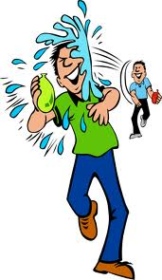

This is it! The Wagion Water Park! Are you ready to get soaked to the bone? If so, this is the place to be!

Taking place at the Lake Side Parade Field, this is the perfect time and place to spend time drenching all of your friends with as much water that you can get your hands on!

BE PREPARED... to get soaked!

There will be a lot! Snacks, souvenirs, and other things available at the ON SITE Trading Post! Things like:

- Pop/ Water

- Chips

- and Hot Dogs

will be available!