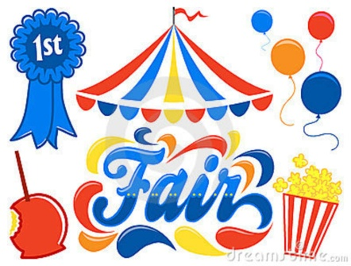

Are you ready for The 2nd Annual Wagion World Fair? Are you ready to make Wagion History !?! This is going to be the biggest, the baddest, the most amazing thing you have ever seen!

With all the great Snacks, Games, Rides, and so many other things to do, you are going to go insane!

I hope you are ready for the best night of your life!

*Don't forget your tickets from registration!!

**Snacks:**

* **Philly Cheese Steak Hoagies**
* **POPCORN!**
* **\*Pizza will be sold at the ON SITE Trading Post**

Games and Rides at the Wagion World Fair consist of:

1. Dunk Tank
2. Ring Toss
3. Bottle Knock Down
4. Football Toss
5. Balloon Darts
6. Basketball Toss
7. Duck Pond
8. Baseball Pitch

AND MORE!