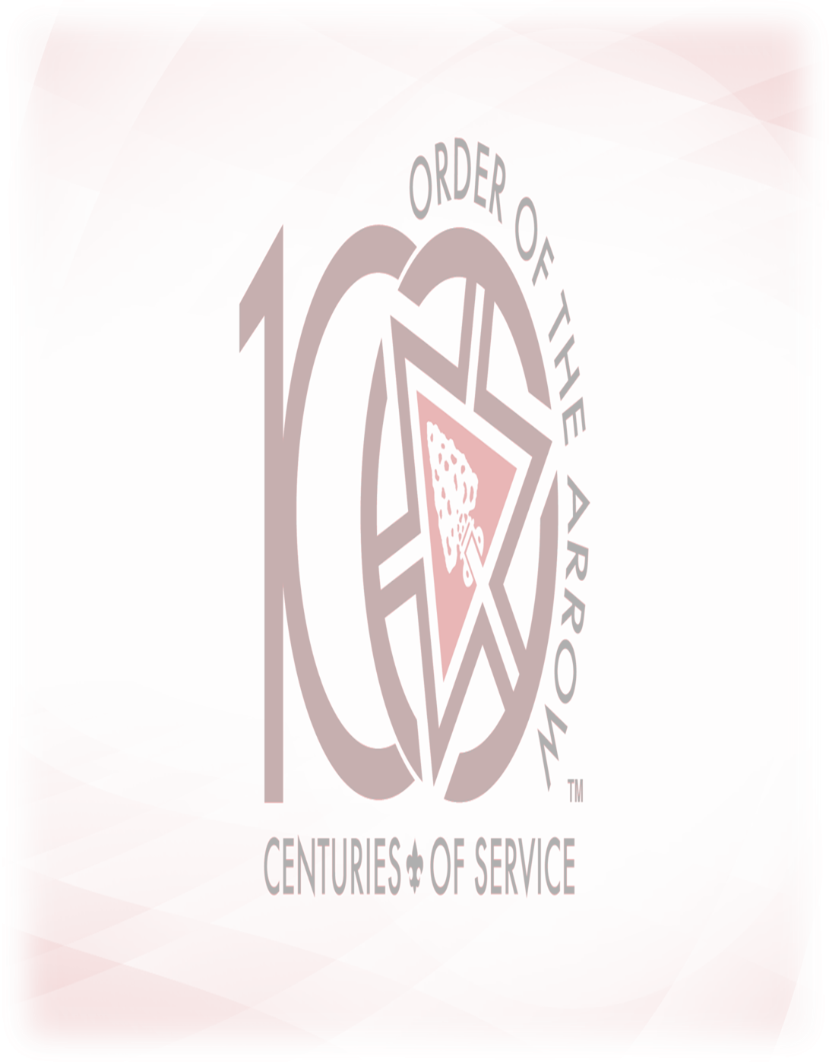Boy Scouts of America
Order of the Arrow
Community Day

June 27, 2015
12:00pm-2:00pm
Westmoreland-Fayette Council, B.S.A.
2 Garden Center Dr.
Greensburg, PA 15601

Free Food, Games, Give Always!
Performances by
Wagion Lodge 6 Drum and Dance Team, Ceremonies Team!

Special Addresses by
Lodge Chief Caleb Maddas,
Lodge Adviser Richard J. Hager,
Scout Executive Martin Barbie!

See more @ www.wagion.org
Like us on Facebook and Follow us on Twitter!

